SELECT*FROM employees;

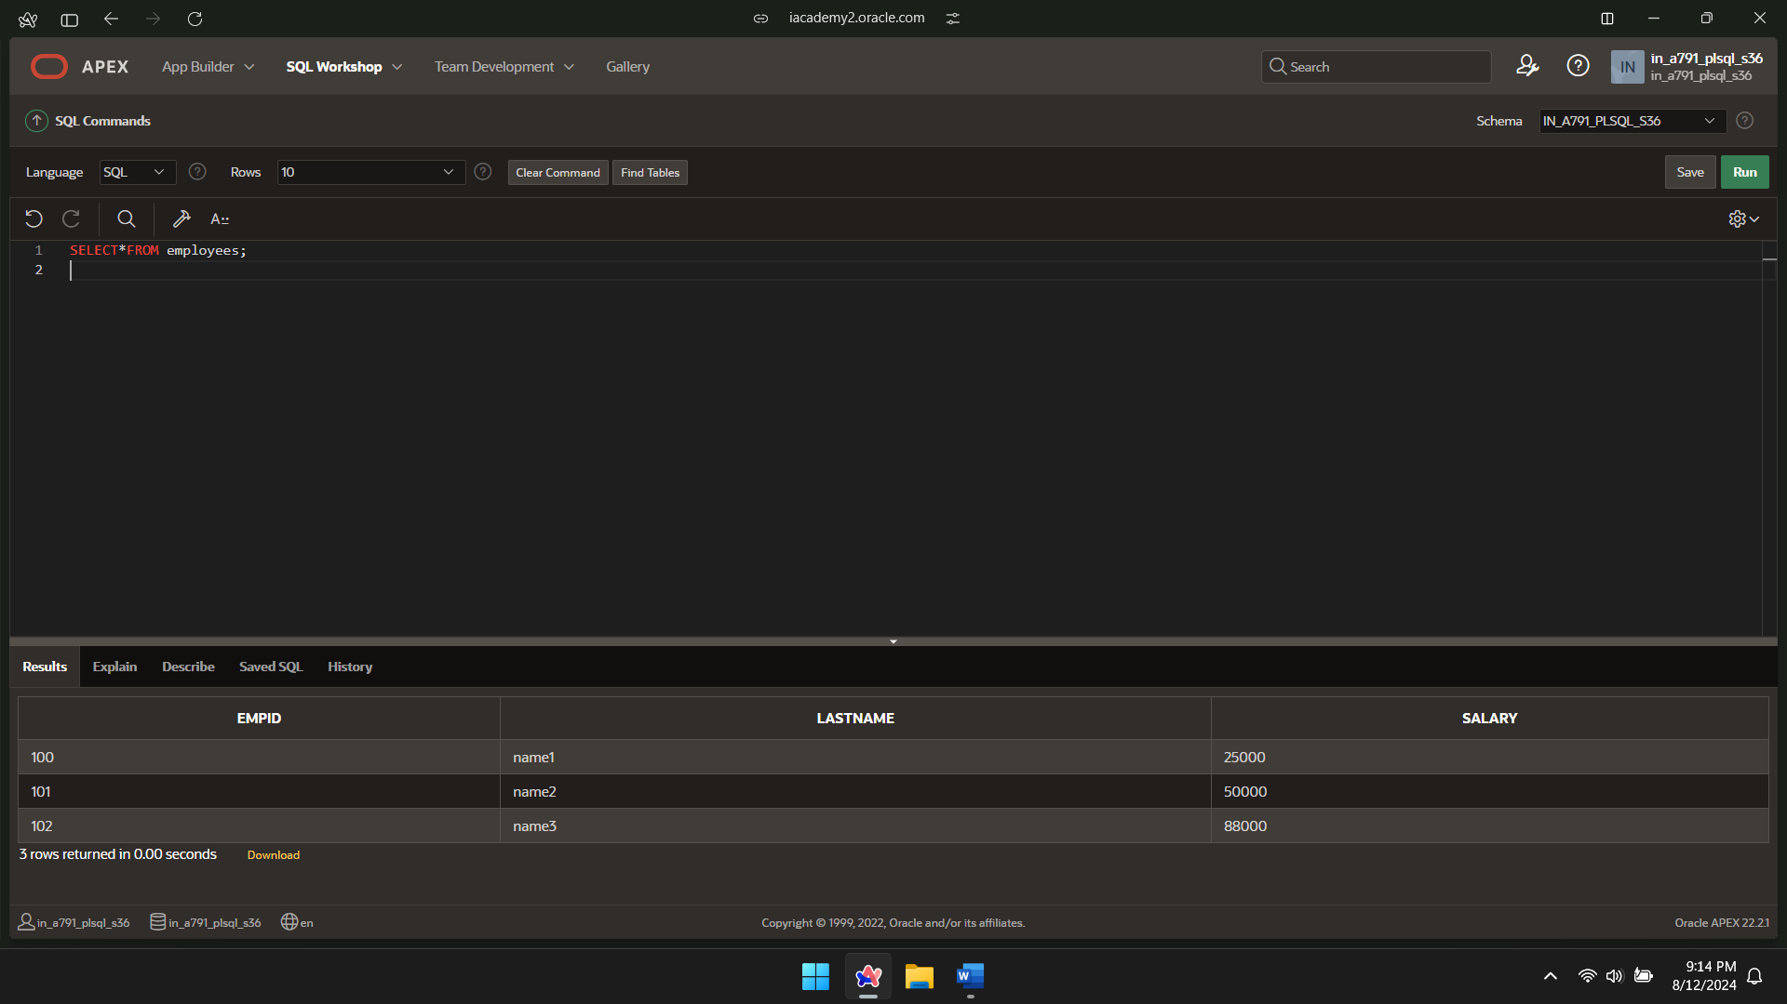

PACKAGE

CREATE OR REPLACE PACKAGE salary_pkg

IS

g_max_sal_raise CONSTANT NUMBER := 0.20;

PROCEDURE update_sal

(p_employee_id employees.empid%TYPE,

p_new_salary employees.salary%TYPE);

END salary_pkg;

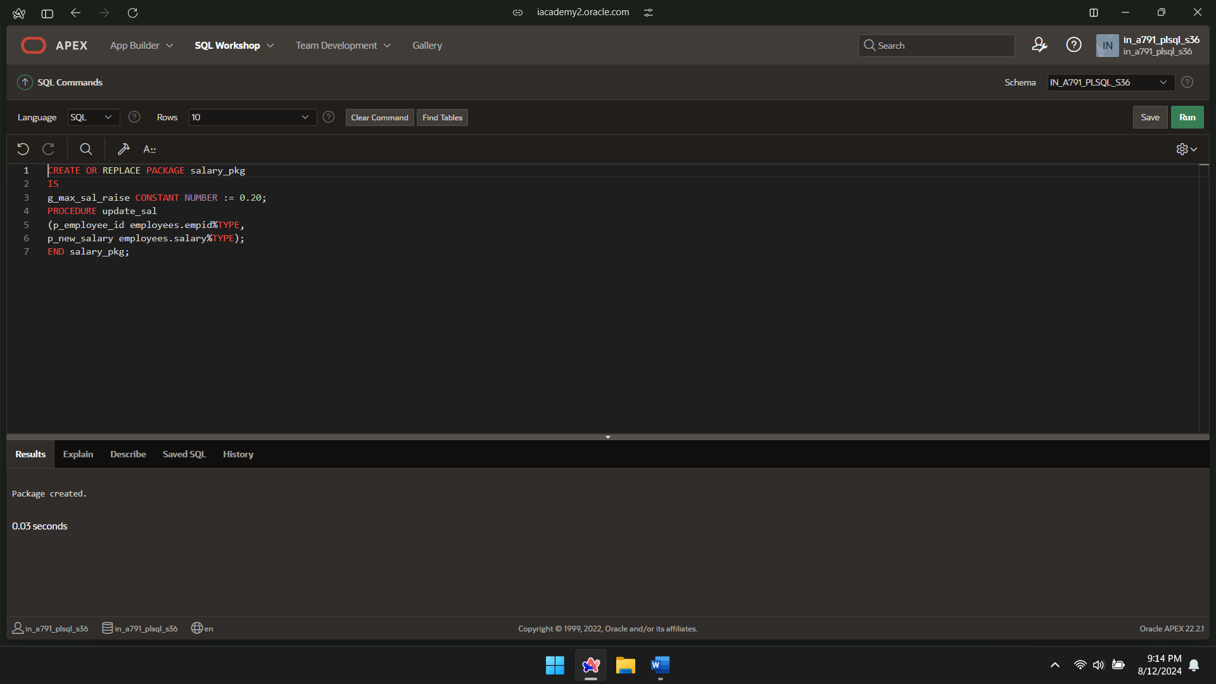

PACKAGE BODY

CREATE OR REPLACE PACKAGE BODY salary_pkg IS

FUNCTION validate_raise

(p_old_salary employees.salary%TYPE,

p_new_salary employees.salary%TYPE)

RETURN BOOLEAN IS

BEGIN

IF p_new_salary >

(p_old_salary * (1 + g_max_sal_raise)) THEN

RETURN FALSE;

ELSE

RETURN TRUE;

END IF;

END validate_raise;

PROCEDURE update_sal

(p_employee_id employees.empid%TYPE,

p_new_salary employees.salary%TYPE)

IS v_old_salary employees.salary%TYPE;

BEGIN

SELECT salary INTO v_old_salary FROM employees

WHERE empid = p_employee_id;

IF validate_raise(v_old_salary, p_new_salary) THEN

UPDATE employees

SET salary = p_new_salary

WHERE empid = p_employee_id;

ELSE

DBMS_OUTPUT.PUT_LINE('high');

END IF;

END update_sal;

END salary_pkg;

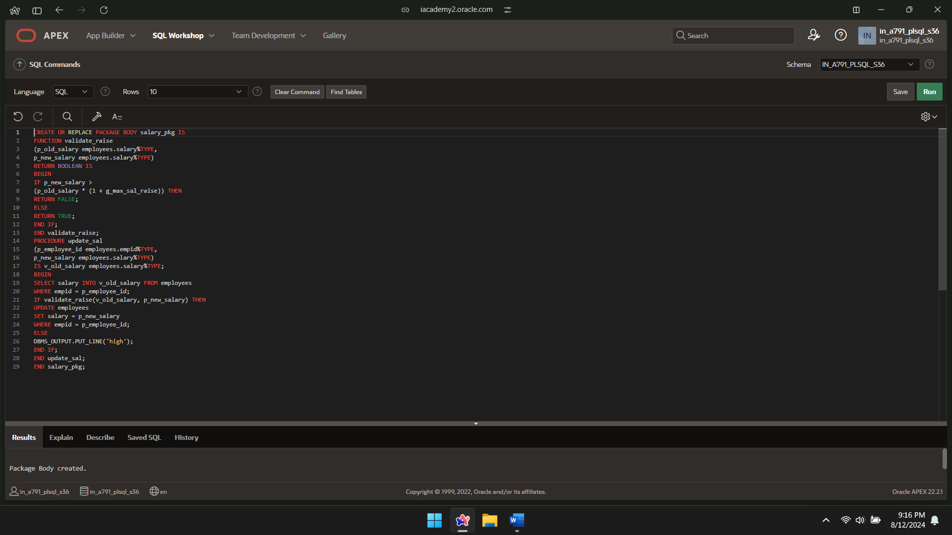

INVOKE PACKAGE

DECLARE

v_number NUMBER;

BEGIN

salary_pkg.update_sal(100,30000);

v_number := salary_pkg.g_max_sal_raise;

END;

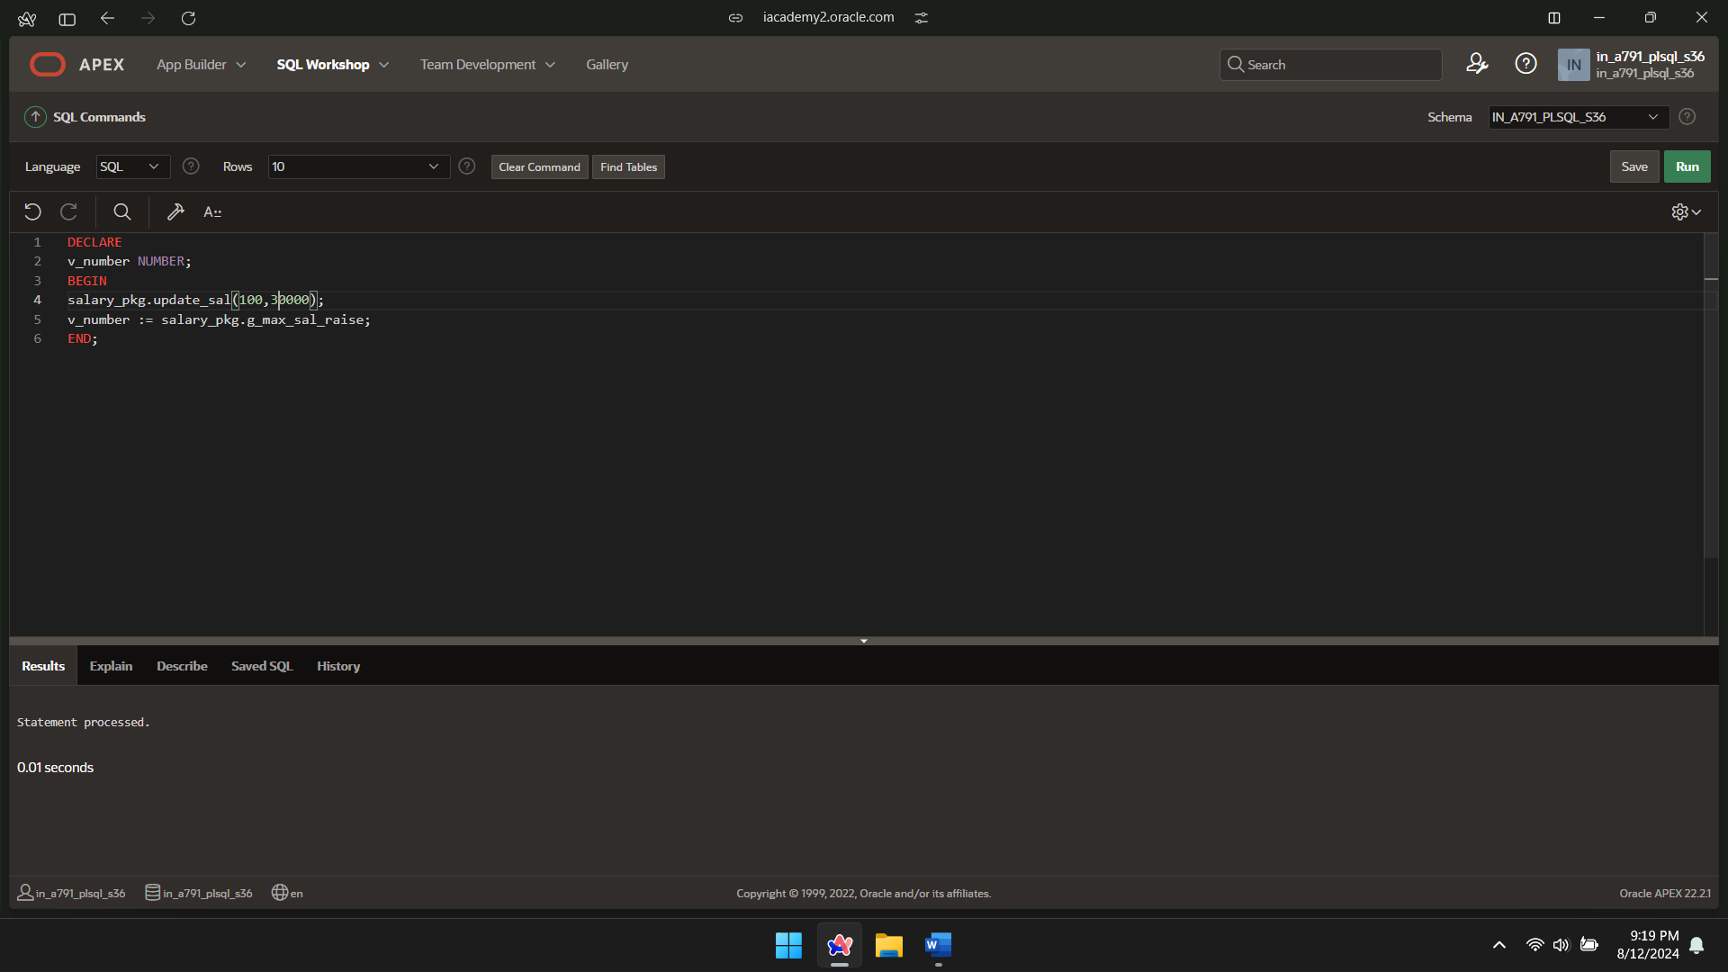

SELECT*FROM employees;

